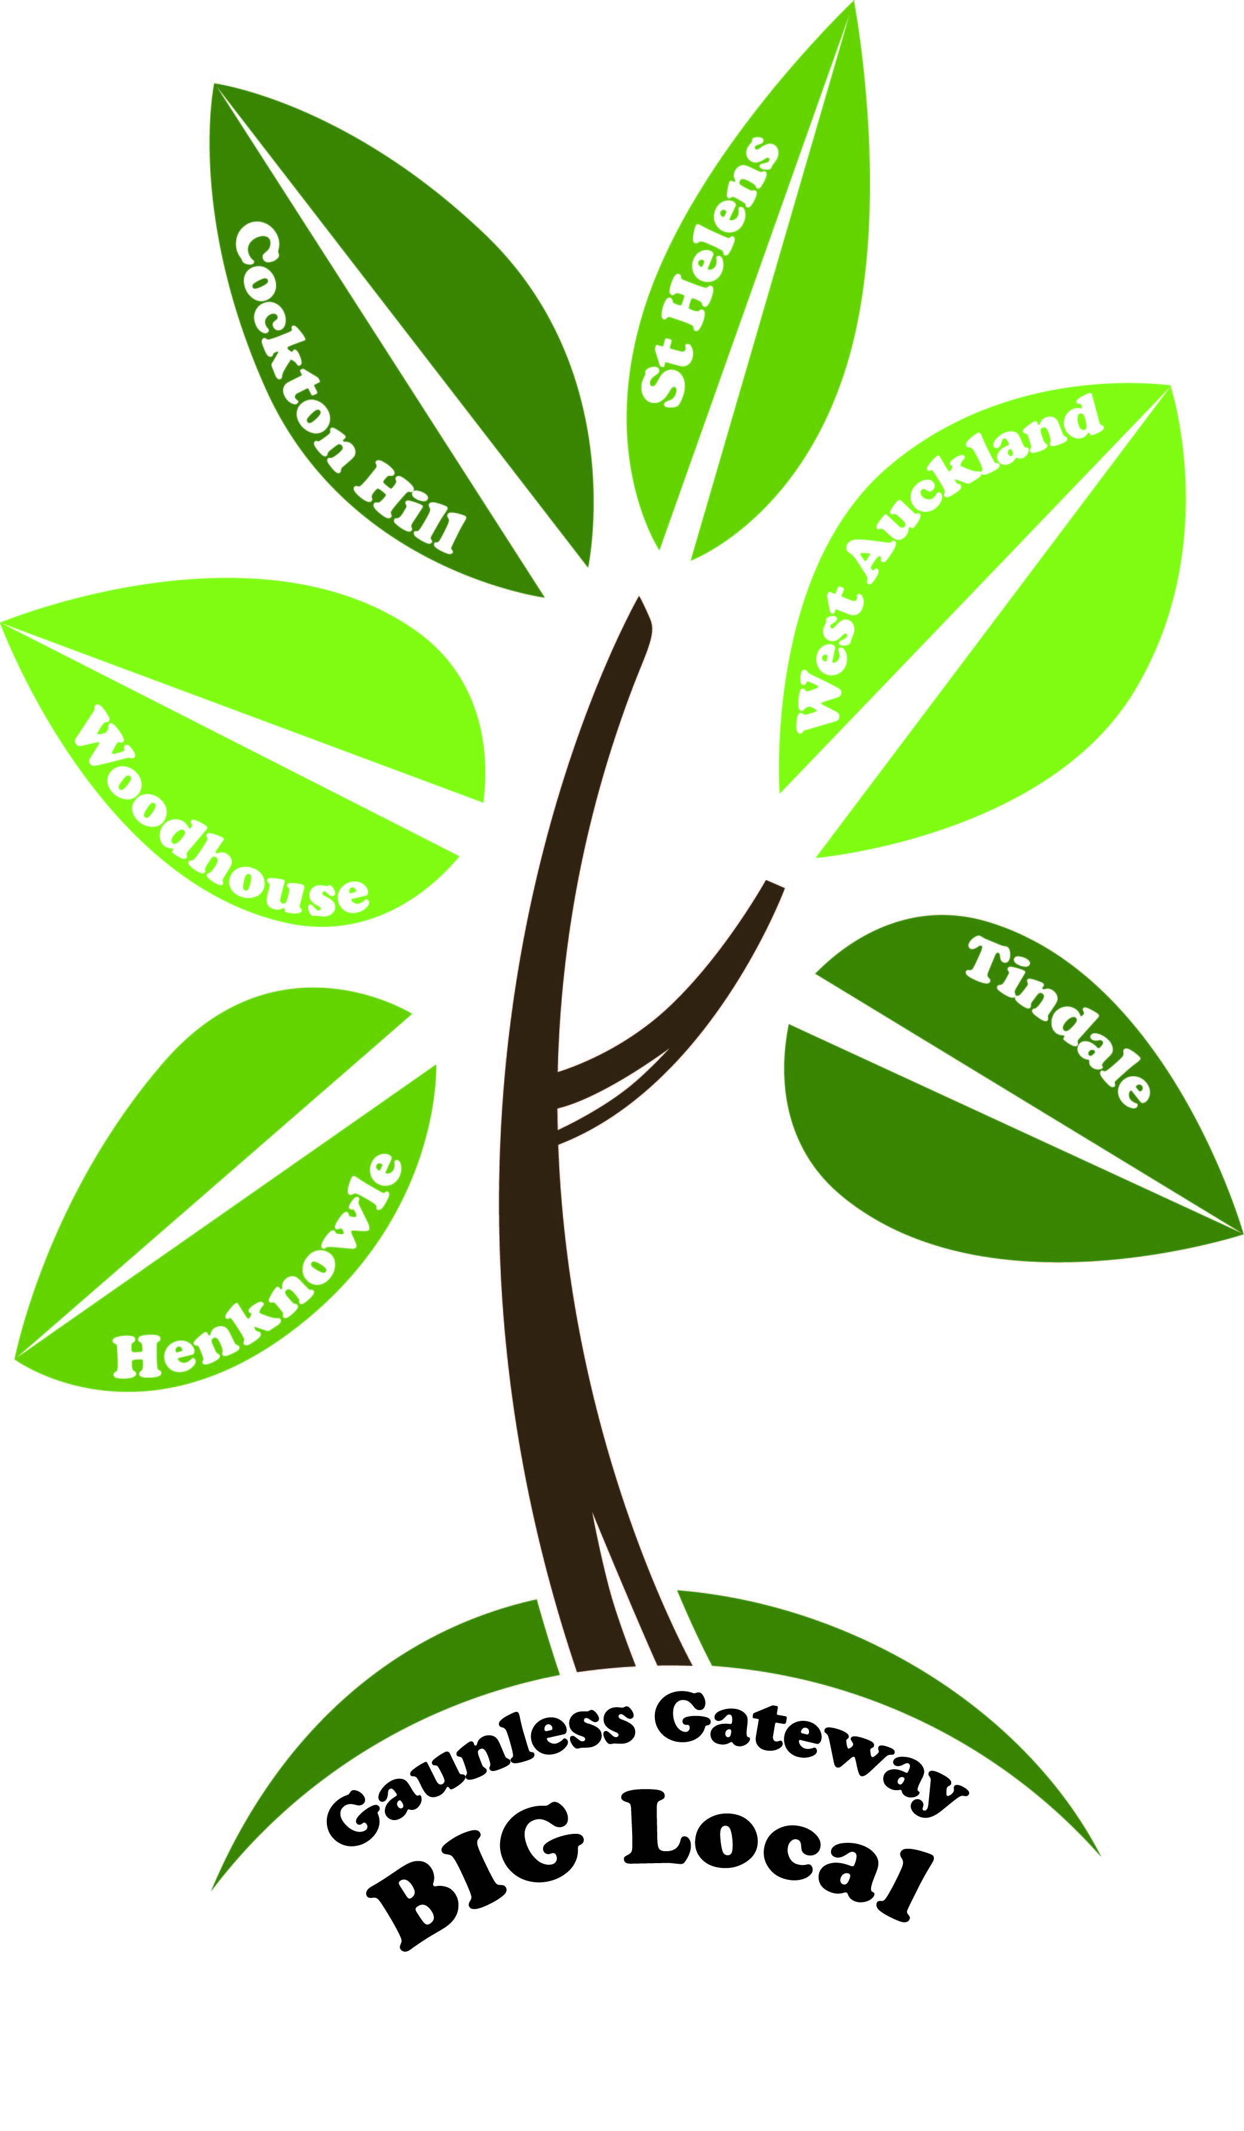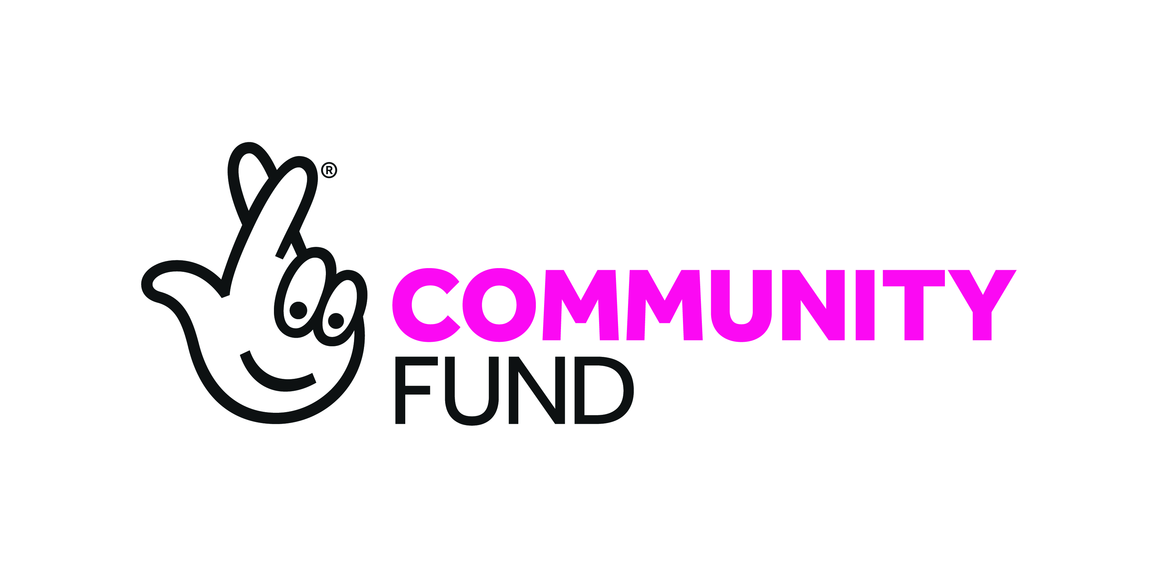

**Gaunless Gateway Full Partnership Monthly Meeting**

**Date: Tuesday 26/02/2019 Time 6:00 pm**

**Venue: Woodhouse Close Church and Community Centre**

**Abbreviations: GGBL** Gaunless Gateway Big Local **LTO** Locally Trust Organisation

**FPMM** Full Partnership Monthly Meeting **DM** Decision Makers **AYCC** Auckland Youth and Community Centre **MMCWG** Media, Marketing and Communications Working Group

**Present:**

**Decision Makers:** Alan Anderson (AA)**,** Lee Brownson (LB), George Smith (GS), Christine Wilson (CW), Lynne Rielly (LR) and Clive Auld (CA)

Barbara Slasor (BS), Susan Graydon (SG), Vicki McGowan (VG), D Boal (DB), Chris Anderson (AA), S Maughan (SM), Ann Williams-Maughan (AWM), Steve Robson (SR), Rupert Wansbury (RW) and Anne Ramshaw (AR)

**Apologies:** Irene Graham, G Salmon, Kelly Rutherford, Jeanette Harold, Grahame White, B Webster

**6:00pm - 6:30pm = Communities in Control** presentation by Vicki McGowan.

A broader overview of the project will be circulated. The initial project started in 2015, with GGBL engaging from 2016. This study is based to demonstrate Communities in Control effect on improving health and wellbeing, partnership engagement has taken place previously. Further interviews are going to be held, as a way to further gain information from individuals.

All participants will receive a £15.00 voucher as a thank you for your time and input. GGBL will receive a payment of £750.00, for their participation in the ongoing project. VM requested to be added to the working group’s distribution list along with the FPMM, this will give a broader flavour of the partnership as a whole. All present DM agreed.

**1. Welcome and Introductions -** Lee Brownson (Chair)

LB opened the meeting by requesting a minutes silence to reflect and respect the sad loss of Kevin Graham. Kevin had been involved in the project from the beginning and was a true community champion. His sad loss came following a battle with an illness and our sincere condolences went to Irene and his family. Several decision makers, along with staff and representative from the LTO attended the funeral to pay our respects.

Kevin would be a big loss to the partnership and that his legacy would live on through the work he did completing the 2018-2020 plan (a living document) on behalf of the partnership.

**Declaration of Interest** – None received

**2. Minutes of the previous meeting** – All present agreed accuracy. Matters arising / action points – no matters arising / all previous action points completed where applicable.

|  |  |  |
| --- | --- | --- |
| **22/01/2019 Action:** | **To be undertaken by:** | **Date to be completed by:** |
| Information on the legal structure around the partnership being able to supply any products. | LTO **Amendment required:**  GA to submit information to DM, if applicable then advice will be sought from the LTO | Before the next FPMM |

|  |  |  |
| --- | --- | --- |
| **Action:** | **Undertaken by:** | **Date to be completed by:** |
| Submit a request to Auckland Academy for a date for a meeting, once instructed by CA. | SG | Before the next FPMM |
| Support BS collate the Community Survey results and align to the relevant themes in the 2018-2020 plan | RW | Before the next FPMM |
| Circulate the Community Survey results to the partnership. | SG | Before the FPMM |
| Incorporate the induction for new DM | JH | After January PACT meetings |
| Add VM to all working groups  Add CA to Intergenerational working  Add DB to MMCWG | SG | Before the next working groups meeting |
| Communities in Control update, to be circulated to the partnership | VM & SG | Before the next working groups meeting |
| Request an update on the GGBL Map / merchandise from G Arnold | SG | Before the next working groups meeting |
| Request feedback from Neil Gardiner, in relation to the plan submission | SR & SG | Before the next working groups meeting |
| Contact Margaret Vaughan in relation to carrying over the under spend | SR | Before the next working groups meeting |
| Finalise the service level agreement | SR | Before the next working groups meeting |
| Submit a plan proposal (No financial expectation) for a promotional video around the GGBL and working group’s roles in the project. | CA | Ongoing |
| All templates to be circulated on completion, to the DM for approval. | BS | Before the next working groups meeting |

**3**. **Financial report (LTO)** report circulated and available on request.

SR gave a breakdown of the financial statement. All present agreed accuracy.

* The format of the financial statement at FPMM is briefer, and adapts a more focused approach (a more in depth text is available on request).
* A meeting between SR,LB, GS and KR, covered topics ranging from – HR / Service Level Agreements / Terms of Reference / Employment between the LTO / GGBL.

All documentation is under review in alignment with the 2018-2020 plan, in addition to the working groups reviewing and revising their current documentation.

**2018-2020 Plan**

This has now been approved by Local Trust. Neil Gardiner (plan reviewer) has given feedback to Local Trust after engaging with the partnership / DM / LTO / GGBL workers.

The LTO and Local Trust are corresponding in regards to the terms and conditions that will apply to the next phase of the approved plan.

The identified under spend will be returned to Local Trust and will be absorbed into the overall GGBL funds held by Local Trust.

* The next draw down will be in line with requested funds from the submitted 2018-2020 plan. Budget lines are flexible but only DM can decide on any changes, all present DM agreed.
* Any funding allocation changes agreed within the budget lines, needs to be shared with the LTO allowing a clearer allocation of the outgoing funds (micro meetings were discussed, to keep all working groups updated).
* SR has submitted the final spend to Local Trust, (Zoe) who is feeding back to the LTO (SR). Discussions between Local Trust, the LTO will be fed back to the partnership.
* LB as Chair of the GGBL will sign off the documentation on behalf of the GGBL partnership upon completion.

**HR update**

KR as lead alongside LB represents HR support from GGBL. C Jones is the operational support for the LTO day to day. There are no flagged areas of concern to report back to the FPMM.

**Small Grants**

SR will be liaising with Margaret Vaughan in the near future, all outcomes will be shared with the DM. Updates on progress, will be filtered down at the next FPMM.

**4. Presentations** (maximum of 15 mins)

**Crackin Toast -** Chris Anderson

Synopsis from the web page: We make films, documentaries and promotional videos. No project too small. Further information / films / projects can be enjoyed [here](https://www.google.com/search?q=crackin+toast&oq=crackin+toast&aqs=chrome..69i57j0l2.8843j0j7&sourceid=chrome&ie=UTF-8) .

A recent project which centred on Bishop Auckland raised £3,500 for the [Butterwick Hospice.](https://www.butterwick.org.uk/ourhospices/butterwickhospicebishopauckland/)

A potential project idea using a replication model was discussed, based on [Woodhouse Pageant - Directed by Crackin Toast](https://l.facebook.com/l.php?u=https%3A%2F%2Fvimeo.com%2Fcrackintoast%2Fpagent%3Ffbclid%3DIwAR1n0eg41oXulzp13klWpy1Cv7NDUSTl66P3qahTZwkZKWxSAEpumyaITvM&h=AT220co-x8uJFJPXio6Zfmf2f5vGZdOaM67aj6A9KrG19rUuKvcwleAA_FxsjuTmDzx3ekXFYSHok5bjQITxYMfCVr_7Xkgm4kYuoSkYgSMpPUKcy1T_97e9rMdPWVv84UDw3CAbjNMJDvrFZIR4c0zKTPZY9CZ8ANQYQKqy-njAVkHPTuNIgFIbtvBgrk2JUQgGJe4JqNPihMpgzhrJwmRarBstY1Zzw_oZoCIy1xmPD5yS3TOcNOQsH_sf7oMkDnGC1CdinJm7NDVsCLxEPdAqB_Ciz2hcDqGXJKBzhLwUQoTy-a9yqqa0NPPX5bONEOymzdIshTLF9lVrb3wvqff623i8jQWgwidR-16h47iFIexmMkj6WuGQ0JyLppExgKItEtXJeLsgzyOsMtkA5uzN2_uJU4VppWeP41JvCHKBO7aaMtEg4YZJlCkq9fDcmMooDkaBUAcgMG7bfWDNwPQsSIsQF9zUtiruUh4-Lu3w9jHzCC9SONPbIgU1o0KucxundNhRLCPsPwwIkO_3mZNdLLXpe9EzlJCfK51O_vBT7A9GnsoVitZD86ZfJLVolb5gCl1Tn_7B-ZjDY-jBGL63zAbmG0p50V08Ayb2Nof78TVDgL8AkbLwtTOBFEp-O4jNWe2k). Another pageant will need the support of a wide range of stakeholders and grant funding sources.

Further details are required before the project proposal can be submitted for consideration to the DM via the relevant working group.

A link into the youth forum for engagement was discussed and will be explored at a more appropriate time.

All present agreed this project could be a great legacy for GGBL, its historical important of the time and the inclusion of the partnership in the project, sits with the identified aims outlined in the 2018-2020 plan.

**5. Worker reports**

**Barbara Slasor’s** worker report was circulated in advance, for any questions with none tabled. The report is available on request.

* **Verbal update on Enactus**

BS gave a verbal update on engagement with Enactus students around their outlined digital project idea, centred on a newspaper to improve area communications. BS has highlighted concerns with the Enactus rep, stressing that a bottom up approach (required from the partnership) must be adopted for the project to be effective and a fit with Big Local ethos.

It must add value to our work and have a positive impact on the community. It must not be perceived as a top down approach in that Enactus students create and design this process without working with the communications working group.

Budget set aside in the 2018-2020 would support a paper version of an ‘online’ newspaper, if this proposal comes to fruition. BS has requested further clarity from Enactus.

Recommendations from report: None submitted

**Susan Graydon** – worker report was circulated in advance, for any questions with none tabled. The report is available on request.

Recommendations from report: None submitted

**Graeme White** - worker report was circulated in advance, for any questions with none tabled. The report is available on request.

* GW submitted his apologies; correspondence had been received via D McCreedy about GW resignation and a discussion around details in the worker took place.
* Funded driver training for GW has cost £1,200 and is unable to be recouped as no arrangement has been included in the service level agreement period between AYCC and the Partnership a contingency plan of £12,000 is in place with an expectation that any short term requirements to recruit a paid driver will be made.
* A meeting was agreed as the best course of action for clarity with D McCreedy at AYCC and GGBL stakeholders LR, CA and AA. This will be reported back at the next FPMM

Recommendation from report: None submitted

**6. Working groups**

It was agreed no project proposals will be considered until after the terms of reference are agreed as fit for purpose by individual working groups. Documents and templates to be completed and to be considered at the next FPMM for consideration.

**Theme 1 – Jobs, Education / Training and Apprenticeship**

Apprenticeship / bursary support - SR is in correspondence with Camilla Race from the Auckland Academy, around the granular details in regards to the apprenticeship proposal submitted by GGBL.

The LTO is in the process of formulating the funding agreement, same as Local Trust – do spend / don’t spend / terms and conditions. Once the collaboration has taken place and documentation is complete, Auckland Academy will have the funds released from the LTO.

SR and Camilla Race have a further meeting in two weeks’ time; SR will liaise with CA who has been invited to attend the meeting. The process is well underway.

GS has stepped down from lead of the Jobs, Education / Training and Apprenticeship working group, due to an increase in work commitments. CA will take over as the Lead.

**Theme 2 – Health and Wellbeing** - no report submitted

**Theme 3 – Intergenerational and Community Activities** - no report submitted

**Theme 4 – Children and Young People report**

LR presented the recommendations from discussions around the terms of reference and project proposal templates for consideration, this was a condensed text from the minutes of the working group, and future reports to decision makers to be circulated in advance of the next full partnership meeting.

|  |  |  |
| --- | --- | --- |
| **Recommendation for decision:** | **Additional information** | **Agreed Yes / No** |
| **a.** | Working groups will have a slight change, allowing each to adapt to their own expectations. | Yes |
| **b.** | If a working group lead or member is unable to fulfil their action what happens | Yes |
| **c.** | Meetings no later than 3rd Monday of the month to enable recommendations to be circulated. | Yes |
| **d.** | In addition, attend and promote at other existing events from other partnership organisations. | Yes |
| **e.** | Host workshops on what is expected and how to complete forms / templates in the partnership. | Yes |
| **f.** | Make clear in the guidelines that projects can apply for different activity projects; however any new organisations will be prioritised. Add section on template asking if they are part of any other group has received funding with disclosure. | Yes |
| **g.** | To develop an annual action plan identifying key actions to meet agreed C &YP outcomes. Examples call out for project ideas twice a year, cut off date and appraisal. | Yes |
| **h.** | Adopt a flexible approach to budget allocated to individual project proposals, each budget line is only an example. All project proposals to identify which theme is financing the project, inform both the other working groups and the LTO. | Yes |
| **I.** | Approach known organisations with track record of delivery or look at supporting existing projects to develop further. | Yes |
| **j.** | To have the youth forum as a standing item on C & YP working group agenda and any update reports / recommendations to be channelled by C & YP working group to FPMM. | Yes |
| **k.** | LB praised the work of the active working groups and acknowledged there is still work to be done. All supporting text to be presented for consideration at the next FPMM. | Yes |

LR recognised a new resident led group ‘West Auckland in Bloom’ and efforts to date. All agreed that this community led project is a “blooming” wonderful addition to our area. This could be replicated all through the partnership and beyond.

**Theme 5 – Reducing Crime and Increasing Community Safety** - no report submitted

**Theme 6 – To support partnership to deliver its aims** - no report submitted

**Theme 7 – Small Grants Scheme**

BS circulated a copy of a proposed leaflet, with information relating to how to apply, further discussion on the delivery of small grants is required as the working group has not met.

Monitoring and Evaluation group, no report available

**Media, Marketing & Communications**

The working group has adapted the Terms of Reference templates; the Children and Young Peoples Working Group have already done a sizeable amount of the generic updates. This framework is being used as a replication model for all other working groups. Individual working groups need to incorporate their own identified aims / outcomes / requirements, in the Terms of Reference this will relate to each groups identified needs.

The Facebook “about us” information is causing confusion, as the website address has been changed from [www.gaunlessgateway.co.uk](http://www.gaunlessgateway.co.uk) to www.gaunlessgateway.weebly.com

Agreed by all BS as admin to change the website address to [www.gaunlessgateway.co.uk](http://www.gaunlessgateway.co.uk)

**7.** **Any other business**:

**Event requests**

* **Train Station Community Event** - Saturday 27th July is not required for engagement this year, but will attend as visitors.
* **March for Men –Prostate Cancer UK** – Saturday 23 March 930-1 pm CW, RW, DB will be in attendance the whole time, manning the stall and CA(DM) will pop along to support manning the stall where possible.

**8.** **Date of next meeting**: Tuesday 26th March 2019 Time: 6pm

Venue: The Vineyard Church Aptec Enterprise Park, 3, Darlington Road West Auckland DL14 9PD